**1.What is Normalization?**

Normalization is the process of organizing data in a database. It includes creating tables and establishing relationships between those tables according to rules designed both to protect the data and to make the database more flexible by eliminating redundancy and inconsistent dependency.

There are three types of normalization:-

1. 1NF (First Normal Form)
2. 2NF (Second Normal Form)
3. 3NF (Third Normal Form)
   1. **1NF (First Normal Form)**

If a relation contains a composite or multi-valued attribute, it violates the first normal form, or the relation is in the first normal form if it does not contain any composite or multi-valued attribute. A relation is in first normal form if every attribute in that relation is single-valued attribute.

A table is in 1 NF if:

* There are only Single Valued Attributes.
* Attribute Domain does not change.
* There is a unique name for every Attribute/Column.
* The order in which data is stored does not matter.

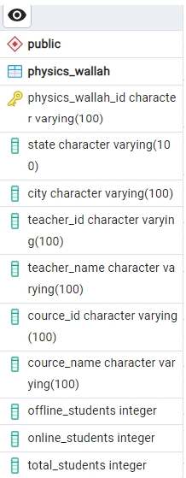

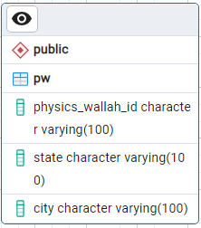

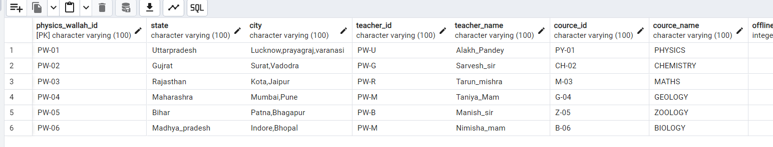

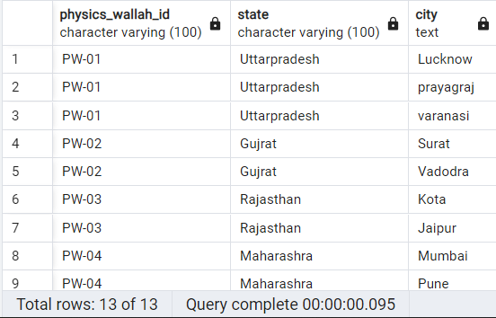

1NF TABLE

* 1. **2NF (Second Normal Form)**

The second Normal Form (2NF) is based on the concept of fully functional dependency. The second Normal Form applies to relations with composite keys, that is, relations with a primary key composed of two or more attributes. A relation with a single-attribute primary key is automatically in at least 2NF. A relation that is not in 2NF may suffer from the update anomalies. To be in the second normal form, a relation must be in the first normal form and the relation must not contain any partial dependency. A relation is in 2NF if it has No Partial Dependency, i.e., no non-prime attribute (attributes that are not part of any candidate key) is dependent on any proper subset of any candidate key of the table.

**A relation that is in First Normal Form and every non-primary-key attribute is fully functionally dependent on the primary key, then the relation is in Second Normal form.**

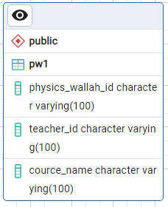

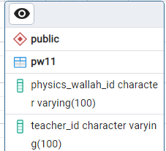

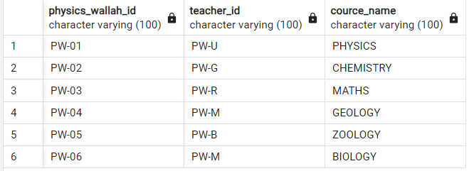

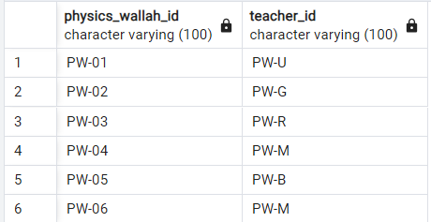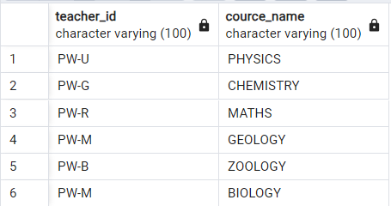

2NF TABLE

* 1. **3NF (Third Normal Function)**

Although Second Normal Form (2NF) relations have less redundancy than those in 1NF, they may still suffer from update anomalies. If we update only one tuple and not the other, the database will be in an inconsistent state. This update anomaly is caused by a transitive dependency. We need to remove such dependencies by progressing to the Third Normal Form (3NF). A relation is in the third normal form, if there is no transitive dependency for non-prime attributes as well as it is in the second normal form. A relation is in 3NF if at least one of the following conditions holds in every non-trivial function dependency X –> Y.

* X is a super key.
* Y is a prime attribute (each element of Y is part of some candidate key).

**A relation that is in First and Second Normal Form and in which no non-primary-key attribute is transitively dependent on the primary key, then it is in Third Normal Form (3NF).**







